Week 8: Implement & Analyze linear algebra and matrix decomposition methods for computational applications.
Linear algebra and matrix decomposition methods are foundational in computational applications, powering everything from machine learning to numerical simulations. Techniques like LU, QR, SVD, and eigenvalue decompositions are widely used for solving systems of equations, dimensionality reduction, optimization, and data compression.
Matrix Decomposition Methods
1. LU Decomposition
- Factorizes a matrix into Lower (L) and Upper (U) triangular matrices.
- Applications: Solving linear systems, numerical stability in simulations, efficient matrix inversion.
2. QR Decomposition
- Splits a matrix into an orthogonal matrix (Q) and an upper triangular matrix (R).
- Applications: Least squares regression, eigenvalue computations, numerical optimization.
5. Eigenvalue & Eigenvector Decomposition
- Factorizes square matrices into eigenvalues and eigenvectors.
- Applications: Principal Component Analysis (PCA), stability analysis, spectral clustering, graph algorithms.

Implement & Analyze linear algebra and matrix decomposition methods for computational applications.
Linear algebra and matrix decomposition methods are foundational in computational applications, powering everything from machine learning to numerical simulations. Techniques like LU, QR, SVD, and eigenvalue decompositions are widely used for solving systems of equations, dimensionality reduction, optimization, and data compression.
8.1. LU Decomposition Program
1. Input Matrix Selection
We consider the system of linear equations:
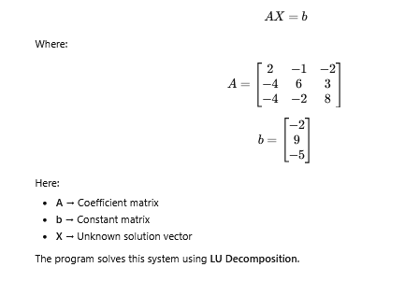
What is LU Decomposition?
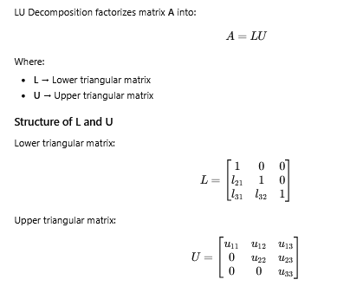
How Calculations are Performed
The program uses the Doolittle Method.
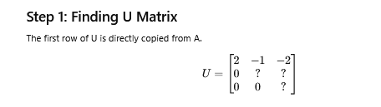
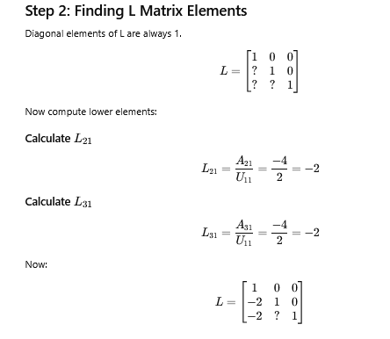
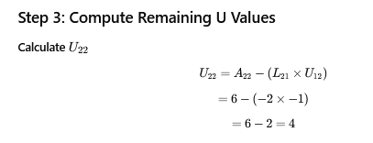
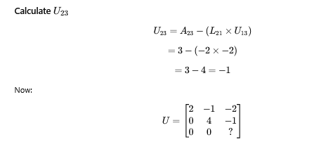
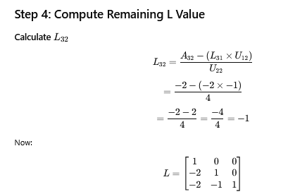
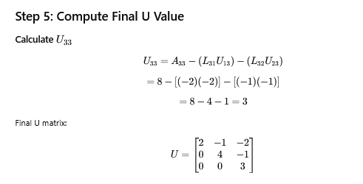
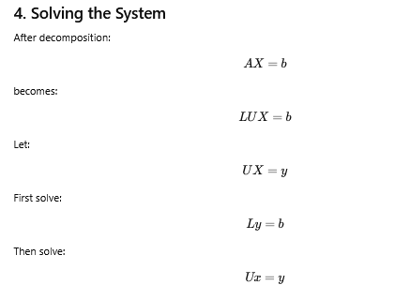
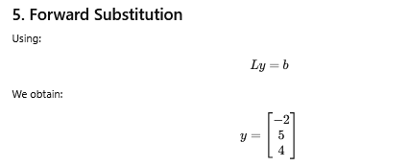
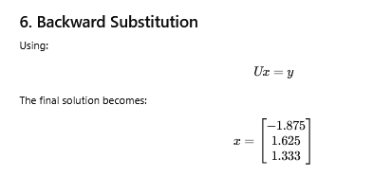
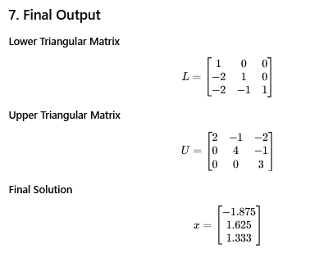
8. Application Used in This Program
This implementation demonstrates the application:
Solving Linear Systems
LU decomposition is widely used in:
- Scientific simulations
- Engineering calculations
- Numerical analysis
- Machine learning optimization
- Matrix inversion methods
because it reduces repeated computations and improves efficiency.
CODE:
# LU Decomposition using Doolittle Method
# Application: Solving Linear Equations Ax = b
import numpy as np
def lu_decomposition(A):
n = len(A)
# Initialize L and U matrices
L = np.zeros((n, n))
U = np.zeros((n, n))
for i in range(n):
# Upper Triangular Matrix
for k in range(i, n):
sum_upper = 0
for j in range(i):
sum_upper += L[i][j] * U[j][k]
U[i][k] = A[i][k] - sum_upper
# Lower Triangular Matrix
L[i][i] = 1 # Diagonal as 1
for k in range(i + 1, n):
sum_lower = 0
for j in range(i):
sum_lower += L[k][j] * U[j][i]
L[k][i] = (A[k][i] - sum_lower) / U[i][i]
return L, U
def forward_substitution(L, b):
n = len(L)
y = np.zeros(n)
for i in range(n):
sum_value = 0
for j in range(i):
sum_value += L[i][j] * y[j]
y[i] = b[i] - sum_value
return y
def backward_substitution(U, y):
n = len(U)
x = np.zeros(n)
for i in range(n - 1, -1, -1):
sum_value = 0
for j in range(i + 1, n):
sum_value += U[i][j] * x[j]
x[i] = (y[i] - sum_value) / U[i][i]
return x
# Input Matrix A
A = np.array([
[2, -1, -2],
[-4, 6, 3],
[-4, -2, 8]
], dtype=float)
# Constant Matrix b
b = np.array([-2, 9, -5], dtype=float)
# Perform LU Decomposition
L, U = lu_decomposition(A)
# Solve Ly = b
y = forward_substitution(L, b)
# Solve Ux = y
x = backward_substitution(U, y)
# Display Results
print("Matrix A:")
print(A)
print("\nLower Triangular Matrix L:")
print(L)
print("\nUpper Triangular Matrix U:")
print(U)
print("\nIntermediate Solution y:")
print(y)
print("\nFinal Solution x:")
print(x)
Expected Output:
Matrix A:
[[ 2. -1. -2.]
[-4. 6. 3.]
[-4. -2. 8.]]

Lower Triangular Matrix L:
[[ 1. 0. 0.]
[-2. 1. 0.]
[-2. -1. 1.]]

Upper Triangular Matrix U:
[[ 2. -1. -2.]
[ 0. 4. -1.]
[ 0. 0. 3.]]

Intermediate Solution y:
[-2. 5. 4.]

Final Solution x:
[-1.875 1.625 1.33333333]

8.2. QR Decomposition
- Splits a matrix into an orthogonal matrix (Q) and an upper triangular matrix (R).
- Applications: Least squares regression, eigenvalue computations, numerical optimization.

1. Input Matrix Selection
The program solves a system of linear equations:
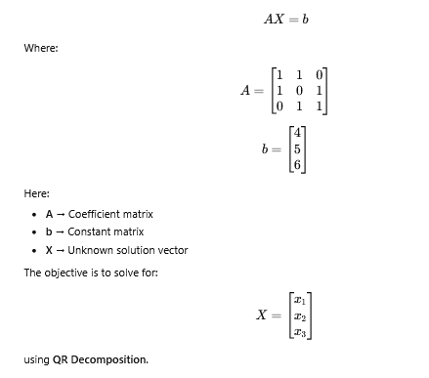
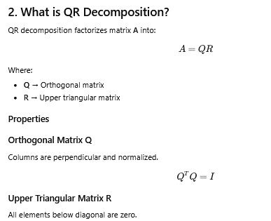
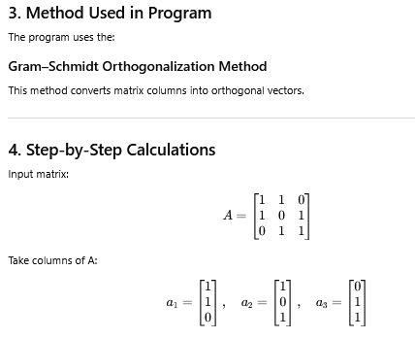
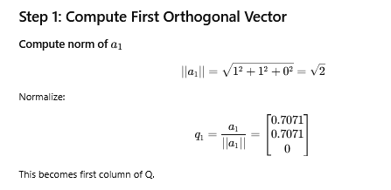
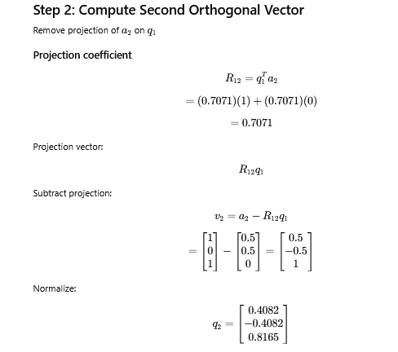
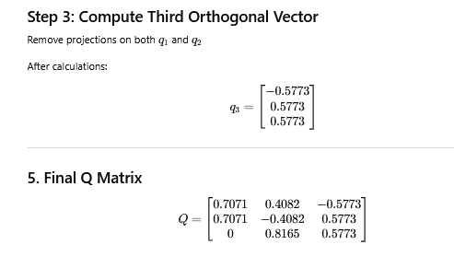
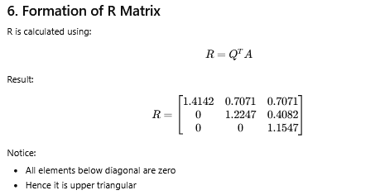
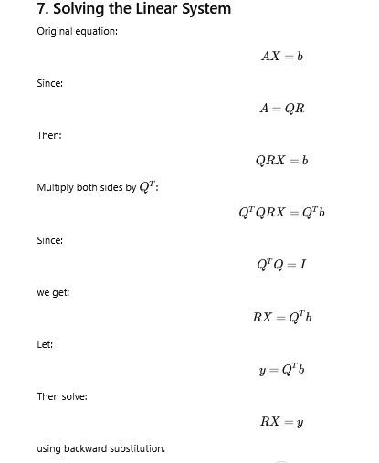
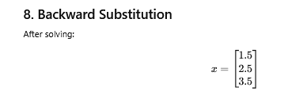
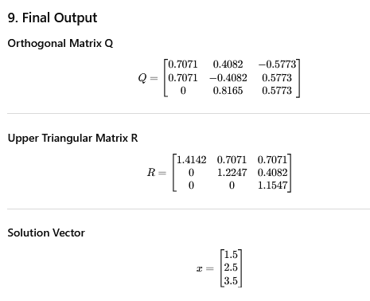
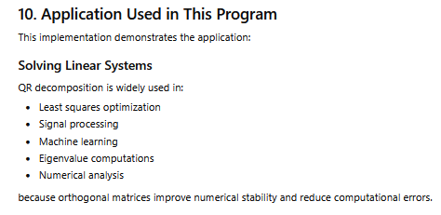
CODE:
# QR Decomposition using Gram-Schmidt Method
# Application: Solving Linear System Ax = b

import numpy as np
def qr_decomposition(A):
n = A.shape[0]
# Initialize Q and R matrices
Q = np.zeros((n, n))
R = np.zeros((n, n))
for j in range(n):
v = A[:, j]
for i in range(j):
R[i, j] = np.dot(Q[:, i], A[:, j])
v = v - R[i, j] * Q[:, i]
R[j, j] = np.linalg.norm(v)
Q[:, j] = v / R[j, j]
return Q, R
def solve_qr(Q, R, b):
# Compute Qᵀb
y = np.dot(Q.T, b)
# Backward substitution to solve Rx = y
n = R.shape[0]
x = np.zeros(n)
for i in range(n - 1, -1, -1):
sum_value = 0
for j in range(i + 1, n):
sum_value += R[i, j] * x[j]

x[i] = (y[i] - sum_value) / R[i, i]
return x
# Input Matrix A
A = np.array([
[1, 1, 0],
[1, 0, 1],
[0, 1, 1]
], dtype=float)
# Constant Matrix b
b = np.array([4, 5, 6], dtype=float)
# Perform QR Decomposition
Q, R = qr_decomposition(A)
# Solve system using QR decomposition
x = solve_qr(Q, R, b)
# Display Results
print("Matrix A:")
print(A)
print("\nOrthogonal Matrix Q:")
print(Q)
print("\nUpper Triangular Matrix R:")
print(R)
print("\nSolution Vector x:")
print(x)

Expected Output
Matrix A:
[[1. 1. 0.]
[1. 0. 1.]
[0. 1. 1.]]

Orthogonal Matrix Q:
[[ 0.70710678 0.40824829 -0.57735027]
[ 0.70710678 -0.40824829 0.57735027]
[ 0. 0.81649658 0.57735027]]

Upper Triangular Matrix R:
[[1.41421356 0.70710678 0.70710678]
[0. 1.22474487 0.40824829]
[0. 0. 1.15470054]]

Solution Vector x:
[1.5 2.5 3.5]

